Report on AES Encryption Using CPU and GPU: Design, Implementation, and Performance Evaluation

1. Introduction
Advanced Encryption Standard (AES) is one of the most widely used symmetric encryption algorithms in modern computing systems. Its security, efficiency, and hardware-friendly structure make it the preferred choice for protecting sensitive information in storage, communication, and distributed systems. As data volumes continue to grow, the computational cost of encrypting large datasets becomes significant, motivating the exploration of hardware accelerators such as Graphics Processing Units (GPUs).
The objective of the project and accompanying code is to implement AES-128 encryption on both CPU and GPU using Python, compare their performance, and evaluate how parallel execution influences throughput. The CPU version follows a standard sequential implementation, while the GPU version employs PyCUDA to run AES operations in parallel across thousands of threads. This report explains the implementation details, execution workflow, performance observations, and insights gained from contrasting these two execution models.

2. Background and Motivation
AES operates on 128-bit blocks and applies a series of transformations—SubBytes, ShiftRows, MixColumns, and AddRoundKey—repeated over multiple rounds. These operations are completely independent for each block of plaintext, which makes AES well suited for parallel computing.
On a CPU, AES is usually executed in a loop where each block is processed one after another. Although modern processors provide improvements such as pipelining and AES-specific instruction sets, the CPU is still bound by its limited thread count.
GPUs, on the other hand, are designed to perform a massive number of identical computations in parallel. AES encryption aligns well with the Single Instruction, Multiple Threads (SIMT) paradigm. Each CUDA thread can encrypt one block independently, allowing thousands of blocks to be processed simultaneously.
This fundamental architectural difference forms the basis for comparing CPU and GPU performance for the same cryptographic workload.

3. Implementation Overview

3.1 CPU Implementation
The CPU version of the program handles encryption in a strictly sequential manner. The plaintext array is divided into 16-byte blocks, and for each block the following steps occur:
- SubBytes – Each byte is substituted using the predefined AES S-Box.
- ShiftRows – Rows of the state matrix are cyclically shifted.
- MixColumns – Columns undergo a matrix transformation to increase diffusion.
- AddRoundKey – The block is XORed with the expanded key material.
This process is repeated across the required number of rounds for AES-128. The time required for encrypting all blocks is measured using Python timing functions. Because processing is linear, runtime increases proportionally to the size of the input data.

3.2 GPU Implementation Using PyCUDA
The GPU implementation is built using PyCUDA to interact with CUDA kernels. Before encryption, the plaintext and key are transferred from host memory (CPU RAM) to device memory (GPU VRAM).
The CUDA kernel assigns one AES block per CUDA thread, enabling parallel encryption. For large datasets, thousands of threads run concurrently, and the GPU performs the same AES transformations as the CPU but on multiple blocks at once.
The GPU performance is measured in three parts:
- Host-to-device transfer time
- Kernel execution time
- Device-to-host transfer time
Separating these metrics helps clarify where overhead occurs and how efficiently the GPU computes compared to the CPU.

4. Execution Workflow
The program follows the sequence below:
- Initialization – A plaintext buffer of user-defined size is created. The AES key is expanded for all required rounds.
- CPU Encryption – The plaintext is encrypted sequentially while recording execution time.
- GPU Preparation – The plaintext is copied to the GPU, memory is allocated, and PyCUDA compiles the kernel.
- GPU Kernel Launch – CUDA threads encrypt all blocks simultaneously.
- Result Retrieval – The ciphertext produced by the GPU kernel is copied back to the host.
- Throughput Calculation – Based on total execution time and data size, throughput (MB/s or GB/s) is calculated for both CPU and GPU.
- Visualization – The code generates a graph comparing CPU and GPU throughput, highlighting the performance difference.

5. Performance Analysis

5.1 Small Input Sizes
For small plaintext sizes (e.g., a few kilobytes), the CPU tends to outperform the GPU. This is primarily due to:
- The overhead of DMA transfers between the CPU and GPU
- Kernel launch overhead
- Underutilization of GPU threads
The GPU’s parallelism does not provide benefits when the workload is too small to occupy its resources fully.

5.2 Medium to Large Input Sizes
When input sizes increase to hundreds of kilobytes or several megabytes, GPU acceleration becomes clearly advantageous. The reasons include:
- Thousands of CUDA threads execute AES operations in parallel
- Kernel computation time scales minimally with input size
- The GPU’s memory bandwidth supports fast data access during encryption
While the CPU’s processing time increases linearly with data size, the GPU handles additional data with only a slight growth in overall execution time.

5.3 Transfer Overhead Considerations
One important observation is that GPU performance is highly dependent on transfer overhead. Although computation on the GPU is extremely fast, copying data in and out of the device can take more time than encryption for smaller inputs. For large datasets, however, the transfer overhead becomes relatively insignificant compared to the gains from parallel execution.

6. Discussion
The results from the program illustrate a key principle in high-performance computing: parallel architectures excel when the workload can be divided into many independent tasks. AES’s block-based structure makes it a perfect candidate for GPU execution, and the observed performance trend aligns with expectations.
Despite its strengths, GPU-based encryption is not always the best choice. For small messages or latency-sensitive applications, a CPU implementation might still be preferable. Moreover, the complexity of managing GPU memory, kernel compilation, and data transfers adds development overhead.
However, for large-scale systems—such as storage encryption, encrypted databases, and high-throughput servers—the GPU’s ability to process millions of AES blocks simultaneously offers a clear advantage.

Observations
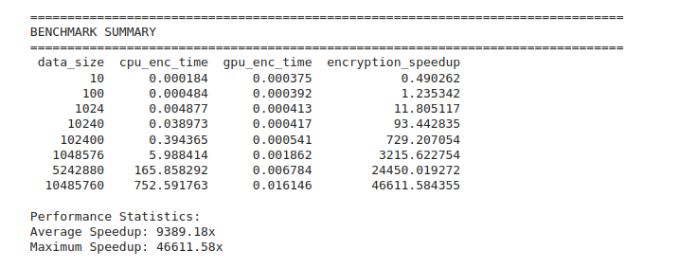
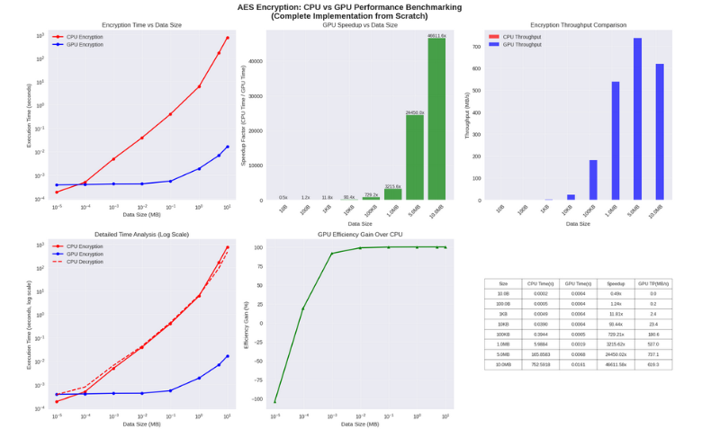

7. Conclusion

This project demonstrates that GPU acceleration can significantly improve AES encryption performance for large datasets. The CPU implementation is simple and predictable but limited by its serial execution. In contrast, the GPU implementation leverages PyCUDA to distribute AES encryption across thousands of threads, resulting in substantially higher throughput as input size grows.
The work highlights the impact of data-transfer overhead, the influence of workload size, and the practical considerations of deploying encryption on parallel hardware. Overall, GPU-based AES encryption is a powerful approach for scenarios requiring high-volume or high-speed data processing.

